
Volume 6 Issue 6 (2022) Pages x-xx
Jurnal Obsesi : Jurnal Pendidikan Anak Usia Dini
ISSN: 2549-8959 (Online) 2356-1327 (Print)

Loose Parts: Stimulation of 21st Century Learning Skills (4C Elements)

Mochamad Sukardjo^{1🖂}, Besse Nirmala², Uswatun Khasanah³, Haerul Annuar⁴
msoekardjo@unj.ac.id ⁽¹⁾ (Teknologi Pendidikan, PPs Universitas Negeri Jakarta, Indonesia)
bessenirmala@rocketmail.com⁽²⁾ (PG PAUD, Universitas Tadulako, Indonesia)
uswatunkhasanah@unulampung.ac.id⁽³⁾ (PG PAUD, Universitas Nahdlatul Ulama Lampung, Indonesia)
haerul.annuar@gmail.com⁽⁴⁾ (PG PAUD, Universitas Tadulako, Indonesia)
DOI: prefix/singkatan jurnal.volume.nomor.ID artikel

Abstract
The process of growth and development of children must be stimulated optimally by utilizing learning resources in the surrounding environment. There are many problems faced by teachers, parents and children in stimulating early childhood development and creativity. Especially during the Covid 19 pandemic which required children to study from home. One of them is the problem of learning in producing students who have 4C competencies (creativity, communication, collaboration, and critical thinking) which are still very limited, especially in Early Childhood Education. Teachers give more assignments contained in the Children's Worksheet even though in the surrounding environment, there are many tools and materials that can be used as learning media that can stimulate children's 4C skills. This research is a qualitative research with a focus on observing, understanding, and analyzing the use of loose parts media to stimulate the 4C skills of early childhood. The results of this study, loose parts are very useful for children in stimulating the 4C skills of early childhood.
Keywords: loose parts, 4C skills, and early childhood.

Copyright (c) 2023 Mochamad Sukardjo, Besse Nirmala, Uswatun Khasanah, Haerul Annaur dst.
🖂 Corresponding author :
Email Address : msoekardjo@unj.ac.id (PPs Universitas Negeri Jakarta, Indonesia)
Received tanggal bulan tahun, Accepted tanggal bulan tahun, Published tanggal bulan tahun

Introduction
Actual data from Richard Florida, et al (2015: 57) in The Global Creativity Index 2015 suggests that the level of creativity of Indonesian children ranks 115th out of 139 countries, with a creativity index of 0.205. This proves that the creativity of early childhood especially in Indonesia must receive special attention and needs to be improved. There are many problems faced by teachers in the learning process as an effort to stimulate early childhood development and creativity. This problem can be seen in the child's developmental achievements when participating in the learning process, namely the child's creativity is limited, the ability to communicate and collaborate is still low (Prameswari, 2020). This is because the teacher gives more assignments which are contained in the Children's Worksheet (Safitri, 2021). Teachers also rarely use loose parts media in learning, teachers tend to use ready-made media and sources (purchased products) there by reducing the creativity of early childhood. In addition, in the process of implementing learning in the classroom, children are more likely to be consumptive, not as creators who create their own tools and play media.
The results of Torrance's research study suggest that at an early age, children's 4C skills should have developed, such as children being able to think fluently (fluency), children being able to think flexibly (flexibility), children being able to think original (originality), and children being able to think in detail/elaboration ( elaboration), (Gencer & Gonen, 2015). 4C skills are not innate by someone but these skills are obtained from a process of training, learning, and experience (Redhana: 2019). Teachers play an important role in preparing superior generations. Not only have the ability but also have the skills needed in this century (Nugraheni, 2019).
This skill is very important given to children from an early age to prepare children to be successful in facing a challenge in a complex life process so that they have a strong personality. Children will need to think critically in counteracting all the influences of technology, be able to analyze what to do and collaborate is also needed so that children have a network in self-development, especially mastery of good communication. When children have very good communication skills, children are able to channel their ideas so that they can find solutions to problems and can have readiness in real life when dealing with an environment where children grow and develop (Lunenburg, 2019: 2240). The ability of children to solve problems comes from continuous physical and psychological activities which need to be stimulated from various investigative activities where children will discover and build knowledge concepts that exist in the environment around Catron and Allen, (Widiastuti, Tegeh & Ujianti, 2018). Based on these problems, it is necessary to develop learning media that can stimulate the 4C skills of early childhood through varied learning and in accordance with 21st century developments.
One of the media that can stimulate early childhood 4C skills is through loose parts media (Flannigan, 2018; Ifrochah, 2021; Prameswari, 2020). Loose parts are pieces that are free to play and cannot be predicted what they will become (Kiewra, C., & Vaselack, E., 2016). These loose parts can be separated and put back together, can be carried, combined, lined up, moved and used with other materials, Haughey (Daly & Beloglovsky, 2014; Siantajani, 2020: 12). This loose parts media is practical, attractive, and easy to find in the environment where children live. Some examples of loose parts media are dry leaves, pinecones, shells, branches, wood and other natural objects. Teachers and parents can collect loose parts media in the surrounding area without paying a fee.
Loose parts media provides a place for children to express their creativity by using materials that can be manipulated, changed, and recreated (Gull, C., Bogunovich, J., Goldstein, S. L, & Rosengarten, T., 2019). Loose parts media not only stimulates aspects of early childhood development, but also helps children connect themselves with their surroundings. Children can use loose parts media to shape and make games according to the ideas of the child (creator). This will develop imagination, communication, collaboration with peers, critical thinking and creativity.
The results of Spencer et al's research (Spencer: 2019) suggest that educators assess loose parts as being able to help children build relationships, develop skills, leadership, gain self-confidence and independence. The results of Spencer's research also show that children who use loose parts media will stimulate an attitude of sharing and caring for the environment. Loose parts media will make children able to connect themselves with their environment. Children need an environment in which they can manipulate, discover, build, evaluate, and modify their own constructs and ideas through play. Children need opportunities to develop a sense of belonging to the environment in which they play. The introduction of loose parts such as scrap materials, sand and water increases the likelihood of children engaging in this type of behavior even in built environments both outdoors and indoors (Caser and Robinson, 2016:6).
Handyman, Benson, Ullah and Telford, (Caser and Robinson, 2016) suggest several benefits of playing with loose parts in the learning process, including: 1) increasing the level of creative and imaginative play, 2) children playing more cooperatively and being able to socialize, 3) children -children are physically more active 4) improve communication skills. In other words, the concept of learning using loose parts media is learning that has relevance and is also meaningful for early childhood. This is because by using loose parts children will have 4C skills as the goal of mastering skills in the 21st century according to the identification of the National Education Association (Redhana, 2019: 2242) including critical thinking, creativity, communication and collaboration.
Nicholson (1971) in Haughey (2017: 8) suggests seven types of loose parts, including: natural-based objects, wood and bamboo, plastic, metal or metal, ceramic or glass, cloth or ribbon, and packaging materials. Loose parts can be used in game-based learning to stimulate creativity and increase passion in children (Gencer & Neslihan Avci, 2017). Natural experiences help form mental structures. This can stimulate children to imagine and foster creativity potential by providing children with free space and the necessary materials (Sutton, 2011). Loose parts provide opportunities for children to increase creativity, collaborative behavior, communication, and cognitive function (Natalie Houser, et. al 2019: 3).
The quality and depth of the outdoor play experience can be enhanced when children use loose parts media (Änggård, 2011; Maxwell et al., 2008). Loose parts media that can be removed, installed, and put together give children the freedom to develop their playing experience based on children's ideas, ideas, and creativity, not games predetermined by the teacher (Änggård, 2011). Philosophy was born since 1970 which was popularized by Simon Nicholson about loose parts in line with the needs of children to have 21st century skills, namely 4C skills, communication, collaboration, creative, and critical thinking (Siantajani, 2020).

Methodology
This research is a qualitative research with a focus on observing, understanding, and analyzing the use of loose parts media to stimulate the 4C skills of early childhood. The subjects in this study were children aged 5-6 years at IT Pelita Hati Kindergarten, Palu City. Primary data collection through direct observation when children are playing loose parts media. The research focus is related to the 4C skills, namely collaboration, communication, creativity, and critical thinking for early childhood, then analyzed using the observation guide from Permen 137 of 2014. In addition, data collection was carried out through interviews with teachers and parents and documenting all activities that have been carried out.
Through an assessment of the feasibility of displaying items, then a deeper analysis is carried out with a view to assessing the feasibility of the contents of the items as a description of the behavioral indicators of the attributes being measured. This assessment is qualitative and judgmental and is carried out by a panel of experts, not by the item authors or the test designers themselves. This is the procedure that produces logical validity.

Results and Discussion
Research and Information Gathering Stage
The research and information gathering stage was carried out by means of a literature study by seeking information and data about loose parts media that can be used to stimulate 4C skills that are in accordance with the characteristics of early childhood and those in the national curriculum, especially in Early Childhood Education. This preliminary study will answer the following questions: 1) are there learning development guidelines or a special curriculum on loose parts media that can stimulate the 4C skills of early childhood?; 2) what is the content of the guidelines for the development of 4C skills learning for early childhood?; 3) is the content in the guide also applicable to Early Childhood Education (ECE)?.
The results of this preliminary study show that there are no guidelines for developing learning, especially loose parts media, in stimulating the 4C skills of early childhood. The second finding relates to the content of the teaching modules and the curriculum for stimulating 4C skills, which are only intended for educational level units ranging from early childhood education to senior high school. Building concepts and developing learning at the elementary school grade level is not even possible to apply in ECE. In addition, the concept of 4C skills that has been formulated is too broad in scope. This is a problem because conceptually the development of thinking skills in early childhood is still at the sensorimotor to concrete operational stages. Introducing the concept of 4C skills namely critical thinking and problem solving, creativity and innovation, collaboration, and communication at a broad level is not easy for children to understand even though children do not directly experience these 4C skills.
The two main results of this literature study gave rise to the idea of ​​the importance of a learning design that can stimulate the 4C skills of early childhood. The next activity is exploring learning conditions to stimulate early childhood 4C skills. The next step taken by the researchers was to hold a focus group discussion (FGD) with several kindergarten teachers in Palu City.
The FGD findings concluded that until now, learning guidelines related to stimulating 4C skills for Early Childhood Education have never been formulated in a comprehensive and holistic manner. Even though the basis for integrative development has been stated in the Child Development Achievement Standards formulated in Permendikbud number 137 concerning National Standards for Early Childhood Education, in the 2013 curriculum reference, it is not found in more detail.
Loose Parts Game
Media There are several loose parts game media used in this study. The media is easy to find around the house and school. The loose parts media used in this study are as follows.
Table 1. Media Loose Parts
No. | Loose Parts Type | Ingredients | Documentation
1. | Grain Loose Parts | 1) pinecones, 2) shellfish, 3) rice colored red, yellow, and green, 4) soybean seeds, 5) nutmeg seeds, 6) corn kernels, 7) green bean seeds, and 8) stones given the colors blue, yellow, and green to make it more interesting. | 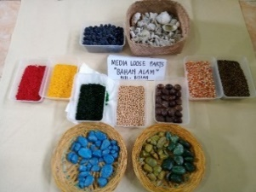  Figure 1. Grains
2. | Loose Parts Natural Materials | 1) bamboo, 2) coconut shell, 3) dry leaves, 4) wooden branches, 5) wooden blocks, and 6) small bamboo. | 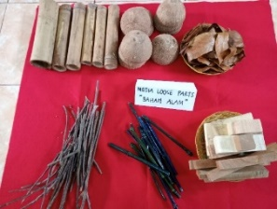  Figure 2. Natural Materials
3. | Used Loose Parts | 1) bottle caps, 2) used plastic spoons, 3) plastic threads, 4) used buttons, 5) used pipettes, 6) used plastic cups, 7) used pipes. | 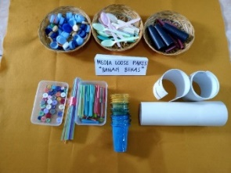  Figure 3. Used
4. | Loose Parts Artificial Materials | 1) styrofoam, 2) pieces of metallic paper, 3) colorful sticks, 4) colorful woolen threads, 5) patchwork pieces, 6) and geometrics from metallic. | 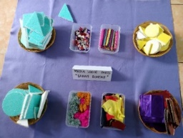  Figure 4. Artificial Materials

Loose Parts Game Implementation
After determining the type of loose parts that will be used by children in playing, the next step is knowing the stages of implementing loose parts games. The flowchart of the implementation of the loose parts game in stimulating the 4C skills of early childhood can be seen in the image below.
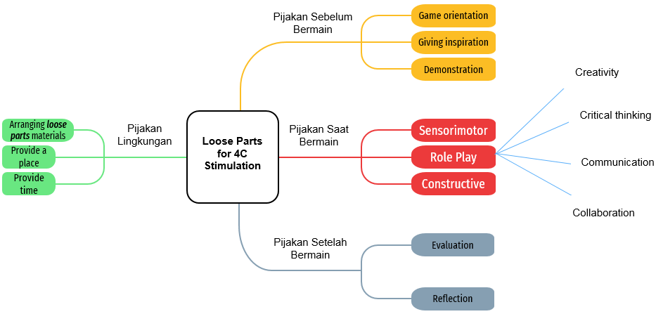
Figure 5. Implementation of Loose Parts Game for 4C Skill Stimulation

Based on this figure, the implementation of the loose parts game to stimulate children's 4C skills is carried out through 4 stages. Stage 1 is the environmental footing. At this stage it consists of 3 activities namely: 1) the teacher first prepares the tools and loose parts materials to be used, 2) the teacher provides a large place so that children can play freely, and 3) the teacher provides time to play so that children can explore all existing materials and make a product in accordance with the idea and creativity.
Stage 2 is the footing before playing. At this stage, there are three activities carried out by the teacher, namely: 1) game orientation where the teacher explains the play activities that will be carried out by the child, 2) providing inspiration to children either through storytelling activities or singing a song according to the theme, and 3) demonstration, namely the teacher gives an example of how to use the loose parts material.
Stage 3 is the footing when playing. At this stage, the teacher provides three kinds of play namely: sensorimotor games, role playing, and development games. In carrying out this play activity, children are free to use various loose parts materials provided by the teacher. Children are free to make any work according to the child's imagination. The teacher only acts as a facilitator who is always ready to provide motivation, scaffolding, and assistance to children. When children do their activities, 4C skills build up by themselves. Teachers only provide support and reinforcement to children so that these skills are properly stimulated.
Stage 4 is the footing after playing. At this stage, the activities carried out are evaluating and reflecting. The teacher evaluates using the question and answer method to the children regarding the meaningful experiences they had that day. The teacher also asked the children's feelings when playing loose partsAt this stage, children are also allowed to tell about works made using loose parts.
Results of the Analysis of Loose Parts
Implementation After the loose parts game was implemented, the researcher then tried to analyze the research findings based on observational data, interviews, and documentation studies. The results of the analysis of the implementation of the loose parts game can be seen in table 2 below.
Table 2. Results of the Analysis of Loose Parts Game Implementation
No. | Activity Documentation | Analysis Results
1 | 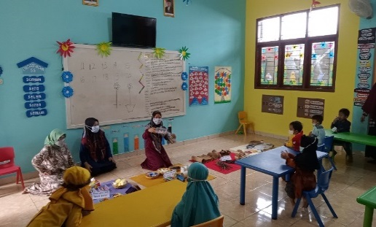  Figure 6. Initial Activities | Before entering the core activities, the teacher first gives instructions regarding the activities to be carried out. The teacher gives an example of how to use loose parts media. The teacher gives freedom to each child to be creative according to their ideas and ideas.
2 | 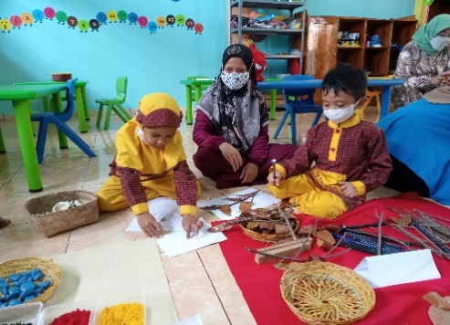  Figure 7. Critical Thinking and Problem Solving | When children play using loose parts media, children choose the type of loose parts themselves to use, namely loose parts made from natural, artificial, used materials, and seeds. Children can solve their own problems and reason about what works they will make. In the picture, it can be seen that the child is using glue to glue the loose parts onto the paper.
3 | 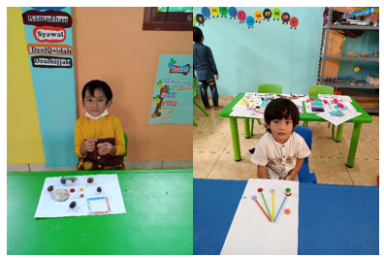  Figure 8. Creativity and Inovation | Children make and create works according to their ideas and imagination. Children are free to be creative by using loose parts materials provided by the teacher. The work created by children is different from other children. This proves that children have a lot of creativity and innovation in creating things.
4 | 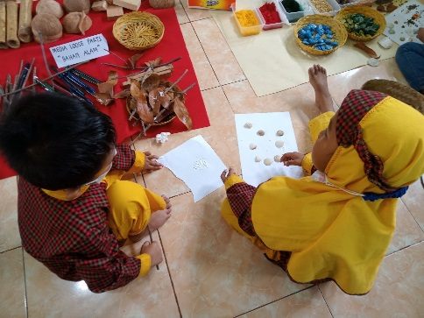  Figure 9. Communication | This aspect of communication arises spontaneously when children play. Children communicate with their friends, ask the teacher, and answer questions. Children's vocabulary increases through playing loose parts activities, especially since the media has just been introduced. Children often ask the teacher how to use the loose parts media.
5 | 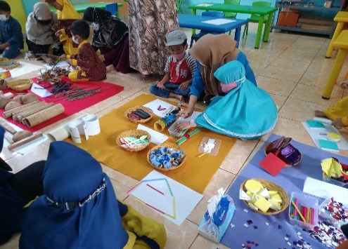  Figure 10. Collaboration | When playing loose parts, children collaborate in making works. Teachers continue to monitor children especially when learning is carried out during the Covid 19 pandemic. Children are free to use tools and loose parts materials and work together in sticking and combining these media into a joint work.

Discussion
Based on the research results above, the use of loose parts media can stimulate the 4C skills of early childhood, namely: critical thinking and problem solving, creativity and innovation, communication, and collaboration. The discussion regarding the 4C skills can be seen below.
Creativity
Playing is the most effective activity for increasing creativity in an educational environment (Tok, 2021). Therefore, teachers should package learning programs based on play activities (Starko 2005; Fleith 2000; Ranjan and Gabora 2013; Ministry of National Education 2013; Mayersky 2015; Bramwell et al. 2011). The importance of playing in the construction of knowledge and learning (Cutter-Mackenzie et al.: 2014). Loose parts provide opportunities for children to have unstructured play that is not dominated by adults (Ridgers, Knowles, & Sayers, 2012; Staempfli, 2009).
Caser and Robinson (2016) suggest that if loose parts media is applied according to the stages of the child's age by using the rules of the learning process according to the child's mindset, it will be able to improve critical thinking skills, try to find creative ideas, be able to solve problems, and stimulate children's developmental achievements. The concept of learning according to Munawar, et al (2019) suggests that when children play using concrete or real objects and come into direct contact with these objects, children can freely explore, observe, and play, children will construct their knowledge and bring out their creativity.
Originality is an important part of the creative process (Runco and Jaeger 2012; Mayersky: 2015). People who think creatively often think differently. There is a way of thinking based on building relationships between unrelated things. Creative thinking involves using different ways of thinking when producing or presenting ideas (Fox and Schirrmacher 2014). Children express their own creativity through thinking (Fox and Schirrmacher: 2014). Researchers have found that creativity is influenced by the social environment (Mullet in Kettler et al. 2018).
In an educational environment that promotes creative thinking, children's creative ideas are considered important and they can express their ideas freely. Children are given time to form their creative expressions. This educational environment is organized with supporting materials that allow children to have their own creative expression and free choice (Fox and Schirrmacher 2014).
Critical Thinking
Critical thinking skills arise when children encounter problems in playing activities. For example, when a child wants to combine loose parts, the child will think about how to combine the two materials. Based on that, the child will think of using glue to glue the material together. In early childhood, habituation to critical thinking needs to be done consistently. This skill can also be honed through the question and answer method, in which the teacher asks several questions to the child. When children find problems in playing, the teacher does not immediately help solve these problems. Teachers should provide support and guidance to children to solve their own problems.
Communications
Communication skills in the ability to effectively articulate thoughts and ideas using oral, written, and nonverbal communication skills in various forms and contexts (Nainggolan, 2019). Communication skills occur when children carry out various conversations with friends during play. Children will develop more systematic, logical, and rational concepts due to social interaction (McLeod, 2018). The teacher can also ask a number of questions related to the work that the child will make so that it stimulates the child's expressive language. At the end of the play activity, children can tell their friends the work they have done. Through this storytelling activity can add to the vocabulary of children.
Collaboration
Collaboration skills in 21st century learning are very important and must be owned by children to achieve meaningful and effective results. The ability to collaborate also prepares children to work in teams. Based on Surowiecki (2005), collaboration in groups with various individual backgrounds will give better results and produce intellectual decisions than someone who is an expert in making decisions.
When the children play loose parts, some of the children work together in groups to complete one piece of work. These collaboration skills can encourage children to help each other, appreciate the work of friends, and be responsible for completing tasks together. Children's skills in collaborating with friends can also stimulate aspects of social-emotional development. Children can help their friends when facing difficulties. This is according to the opinion of Ramani & Brownell, namely an activity designed together in certain situations, allows problem solving skills to develop from cooperative interactions (Ramani & Brownell, 2014).

Conclusion
The 4C skills within the 21st century learning framework are abilities that all children must possess and achieve. This is because 4C skills will provide opportunities for children to prepare themselves to improve competence in facing increasingly complex globalization and workplace challenges in the 21st century. The results of this study provide evidence that through the use of loose parts media, it will stimulate children's 4C skills, namely creativity (making various original works according to children's ideas and creativity), critical thinking (children can find their own solutions to problems encountered when playing loose parts ), communication (through play activities, children always interact with teachers and peers so that it adds to the child's vocabulary), and collaboration (children can work together and help each other when playing and making loose parts works). Teachers are advised to use loose parts media and give children the freedom to play to develop all their potential so that children can develop according to their times.

Acknowledgment
First, the researcher gives thanks to the presence of Allah SWT for His mercy and grace so that the researcher can finish this article. The researcher also expresses his highest gratitude to all the reviewers who have provide valuable criticism and suggestions for the improvement of this paper to this paper already published.

References
Änggård, E. (2011). Childrens gendered and non-gendered play in natural spaces. Children, Youth, & Environments, 21(2), 5–33. https://doi:2110169830378d.

Bramwell, Gillian, Rosemary C. Reilly, Frank R. Lilly, Neomi Kronish, and Revathi Chennabathni. (2011). “Creative Teachers.” Roeper Review 33 (4): 228–238. https://doi:10.1080/02783193.2011.603111
Daly, L., & Beloglovsky, M. (2014). Loose Parts: Inspiring play in young children, vol 1. Redleaf Press.
Flannigan, C., & Dietse, B. (2017). Children, outdoor play, and loose parts. Journal of Childhood Studies, 42 (4), 53. https://doi.org/10.18357/jcs.v42i4.18103.
Fox, Jill E., and Robert Schirrmacher. 2014. Çocuklarda Sanat ve Yaratıcılığın Gelişimi [Art and Creative Development for Young Children]. Translation from 7th ed. Translation Editor Neriman. Aral & Gökhan Duman. Ankara: Nobel
Gencer, A. A., & Gonen, M. (2015). Examination of The Effects of Reggio Emilia Based Projects on Preschool Children’s Creative Thinking Skills. Procedia–Social and Behavioral Sciences, 186 (312), 456-460. https://doi.org/10/1016/j.sbspro.2014.04.120
Gencer, A.A., & Avci, N. (2017). The Treasure in Nature! Loose Parts Theory. Current Trends in Educational Sciences, 9. Ata Akturk, A., Demircan, H. Ozlen, Senyurt, E., & Cetin, M. (2017). Turkish early childhood education curriculum from the perspective of STEM Education: A document analysis. Journal if Turkish Science Education, 14(4), 16-34. https://doi.org/10.12973/tused.10210a
Gibson, J., L., Cornell, M., & Gill, T. (2017). A Systematic Review of Research into the Impact of Loose Parts Play on Children’s Cognitive, Social, and Emotional Development. School mental health, 9(4), 295-309. https://doi.org/10.1007/s12310-017-9220-9.
Gull, C., Bogunovich, J., Goldstein, S. L, & Rosengarten, T. (2019). Definitions of loose parts in early childhood outdoor classrooms a scoping review. The International Journal of Early Childhood Environmental Education, 6 (3), p. 37.
Haughey, S. (2017). Loose Parts: A Start-Up Guide. Fairy Dust Teaching.
Houser, N. E., Cawley, J., Kolen, A. M., Rainham, D., Rehman, L., Turner, J., & Stone, M. R. (2019). A Loose Parts Randomized Controlled Trial to Promote Active Outdoor Play in Preschool-aged Children: Physycal Literacy in the Early Years (PLEY) Project Methods and Protocols, 2(2), 27. https://doi.org/10.3390/mps2020027.
Imamah, Zakiyatul & Muqowim. (2020). Pengembangan Kreativitas dan Berpikir Kritis pada Anak Usia Dini melalui Metode Pembelajaran Berbasis STEAM and Loose Parts. Yinyang: Jurnal Studi Islam, Gender, dan Anak. p-ISSN: 1907-2791. https://doi.org/10.24090/yiyang.v15i2.3917.
Kiewra, C., & Vaselack, E. (2016). Playing with nature: supporting preschoolers creativity in natural outdoor classrooms. International Journal of Early Childhood Environmental Education, 41 (1), 70-95.
Lestariningrum, Anik & Intan Prastihastari Wijaya. (2020). Penerapan Bermain Loose Parts untuk Kemampuan Memecahkan Masalah Sederhana Anak Usia 4-5 Tahun. Jurnal Pedagogika, e-ISSN: 2716-0580, volume 11, nomor 2.
Maxwell, L. E., Mitchell, M. R., & Evans, G. W. (2008). Effects of play equipment and loose parts on preschool children’s outdoor play behavior: An observational study and design intervention. Children, Youth, & Environments, 18(2), 36–63. doi: https://10.7721/chilyoutenvi.18.2.0036.
Mayersky, Mary. 2015. Creative Activities and Curriculum for Young Children. 11th ed. Stamford, CT: Cengage Learning.
McLeod, S. (2018). Lev Vygotsky. Simply Psychology. https://www.simplypsychology.org/vygotsky.html
Mullet, Diana R., Amy Willerson, Kristen N. Lamb, and Todd Kettler. 2016. “Examining Teacher Perceptions of Creativity: A Systematic Review of the Literature.” Thinking Skills and Creativity, 21: 9–30. doi: https://10.1016/j.tsc.2016.05.001.

Nugraheni, A. D. (2019). Penguatan Pendidikan bagi Generasi Alfa melalui Pembelajaran STEAM Berbasis Loose Parts pada PAUD. Seminar Nasional Pendidikan dan Pembelajaran, 2019, 512-518.
Nurjanah, Novita Eka. (2020). Pembelajaran STEM Berbasis Loose Parts untuk Meningkatkan Kreativitas Anak Usia Dini. Jurnal Ilmiah Kajian Ilmu Anak dan Media Informasi PAUD, JAI V (1) (2020), ISSN: 2528-3359. https://doi.org/10.33061/jai.v5i1.3672.
Pamungkas, B. (2020) Pembelajaran Abad 21. www.tripven.com/pembelajaran-abad-21/ (diakses pada tanggal 10 September 2021).
Prameswari, Titania Widya & Anik Lestariningrum. (2020). STEAM Based Learning Strategies by Playing Loose Parts for the Achievement 4C Skills in Children 4-5 Years. Jurnal Efektor, volume 7 issue 1, 2020, pages 24-34. DOI: https://doi.org/10.29407/e.v7i2.14387
Puspita, W.A, (2019). Penggunaan Loose Parts Dalam Pembelajaran Dengan Muatan STEAM. Jurnal Pendidikan Non Formal. Vol 2(2).
Ramani, G. B., & Brownell, C. A. (2014). Preschoolers’ Cooperative Problem Solving: Integrating Play and Problem Solving. Journal of Early Childhood Research, 12(1), 92–108. https://doi.org/https://doi.org/10.1177/1476718X13498337
Ranjan, Apara, and Liane Gabora. (2013). “Creative Ideas for Actualizing Student Potential.” In Teaching Creatively and Teaching Creativity, edited by Mary B. Gregerson, Heather Snyder, and James C. Kaufman, 119–131. New York: Springer. https://doi.org/10.1007/978-1-4614-5185-3_9.
Redhana, I.W. (2019). Mengembangkan Keterampilan Abad ke-21 dalam Pembelajaran Kimia. Jurnal Inovasi Pendidikan Kimia, 13 (1). https://doi.org/10.15294/jipk.v13i1.17824.
Reagan, M. (2016). STEM-Infusing the Elementary Classroom. California: Corwin, a Sage Publishing Company.
Richard, Florida, dkk. (2015). The Global Creativity Index 2015. Toroton: The Martin Prosperity Institute.
Richey, Rita C, and James D. Klein. (2007). Desaign and Development Research: Methods, Strategies, and Issues. New Jersey: LEA.
Runco, Mark A., and Garett J. Jaeger. 2012. “The Standard Definition of Creativity.” Creativity Research Journal 24 (1): 92–96. Doi: https://10.1080/10400419.2012.650092.
Safitri, Dewi, Anik Lestariningrum. Penerapan Media Loose Part untuk Kreativitas Anak Usia 5-6 Tahun. Kiddo: Jurnal Pendidikan Islam Anak Usia Dini; Vol. 2 No 1, 2021 DOI: https://10.19105/kiddo.v2i1.36.
Siantajani, Y. (2020). Loose Parts. Material Lepasan Otentik Stimulasi PAUD. Semarang: PT Sarang Seratus Aksara.
Spencer, R. A., Joshi, N., Branje, K., McIsaac, J. L. D., Cawley, J., Rehman, L., Kirk, S. F. L., & Stone, M. (2019). Educator Perceptions on the Benefits and Challenges of Loose Parts Play in the Outdoor Environment of Childcare Centers. AIMS Public Health, 6(4), 461. doi: https://10.3934/publichealth.2019.4.461.
Starko, Alane J. (2005). Creativity in the Classroom: Schools of Curious Delight. 3rd ed. Mahwah, N.J.: Lawrance Erlbaum Associates Publishers.
Surowiecki, J., (2005). The Wisdom of Crowds. New York: Anchor.
Sutton, M. J. (2011). In the Hand and Mind: The Intersection of Loose Parts and Imagination in Evocative Settings for Young Children. Children Youth and Environments, 408-424.
Tok, E. (2021). Early childhood teachers’ roles in fostering creativity through free play. International Journal of Early Years Education, 1–13. doi: https://10.1080/09669760.2021.1933919.
Widiastuti, E., Tegeh, M., Ujianti, PR. (2018). Pengaruh Pendekatan Saintifik terhadap Kemampuan Pemecahan Masalah pada Anak Kelompok B di TK. Jurnal Pendidikan Anak Usia Dini Universitas Pendidikan Ganesha, vol 6 (2), 241-250.

